Application & Deployment

1. Open the following github repository [https://github.com/ZeroToHero-2016/JavaDocs/tree/master/Servlets/Day 1/](https://github.com/ZeroToHero-2016/JavaDocs/tree/master/Servlets/Day%201/) and copy the content to your forked github repository.
2. Go to the file location where you have copied the sources and open the project from the Code\exercises folder.
3. Run maven clean install
4. Run maven tomcat7:deploy-only under the tomcat plugin

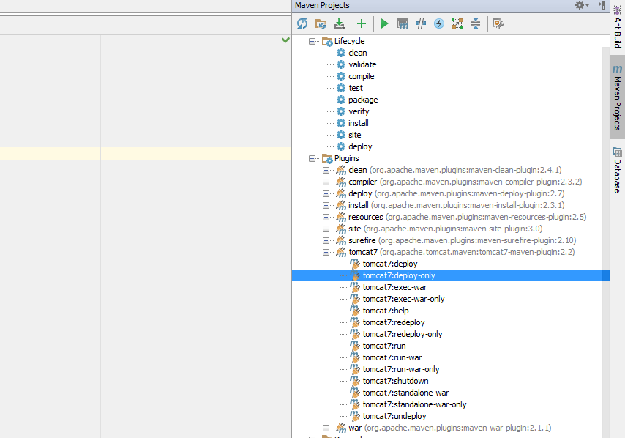

1. Open browser and insert <http://docker.local:49100/servlet-app/> url

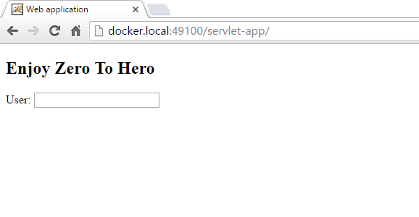

1. Insert some text into “User” input press enter and wait for server response

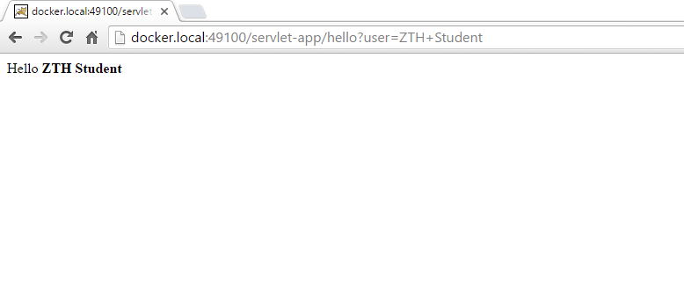

1. To update the web application deployed on the Docker tomcat container follow these stepts:
   1. Change the line “<h2>Enjoy Zero To Hero</h2>” from the index.html to

<h2>I am enjoying zero to hero</h2>

* 1. Run mvn clean install
  2. Run maven tomcat7:undeploy under the tomcat plugin
  3. Run maven tomcat7:deploy-only under the tomcat plugin
  4. Check to see if the web page has updated

